**Team Name:**

Kong

**Members:**

Bader Albader

Jacob Tran

Tyler Valentine

Garrett Senor

Chuck Mezhir

**Database Design Process:**

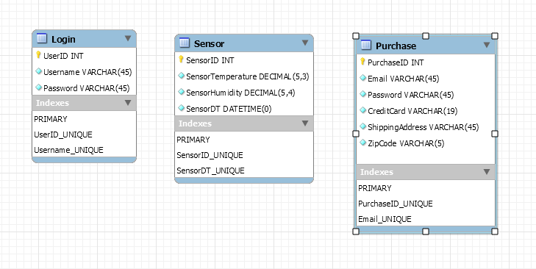 We decided to use MySQL as our database software. We created entity relations in the model tool to represent relationships between tables in necessary.

We then populated each table to test usability.

The SQL scripts to generate and test our database can be found on github: kong\Documents\DB Design

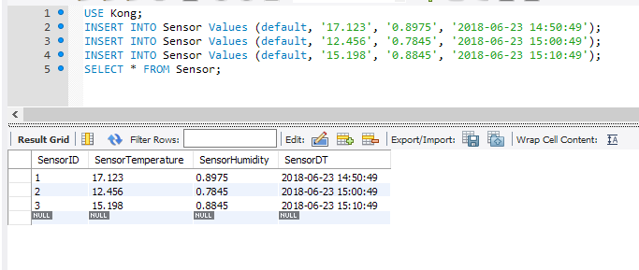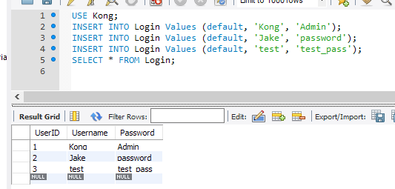

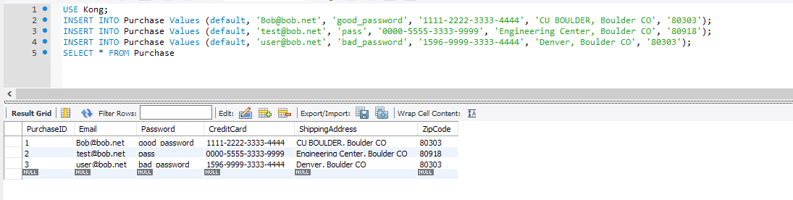

LINK TO SQL SCRIPTS:

<https://github.com/albader94/kong/tree/master/Documents/DB%20Design>

Scrum Notes 6.26.18

Tyler- Created landing page, new customer account creation page, and successful purchase page for frontend. Going forward will be working on current and historical data pages. Need to meet with Charles to see where his website progress is and meet with Bader to determine how to integrate hardware data onto website.

Jacob- Completed framework for database and populated with dummy data to perform testing. Tested database and generated screenshots for milestone 3 and completed submission for milestone 3. Going forward will be working with Garrett on integrating NodeJS with database level.

Garrett- Working on integrating NodeJS with html and database. Worked with Jacob on database design and testing. Going forward will be finishing nodeJS implementation, determining exactly what information will be coming from website and how to send it to database, and determining how to send hardware data to database and website.

Bader (absent from scrum, communicated via slack)- Completed setup of raspberry pi and wrote code and wired sensors. Hardware aspect is basically complete needs to test circuits to finalize. Going forward needs to meet with Garrett to determine how sensor data will be sent to front and back ends.

Charles (absent from scrum)- Uploaded templates for potential websites. Going forward needs to help Tyler with finalizing of front end and integration of sensor data.